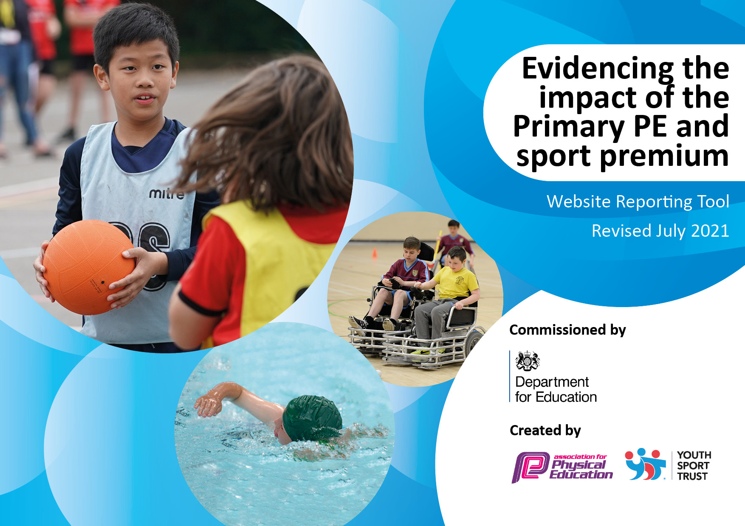

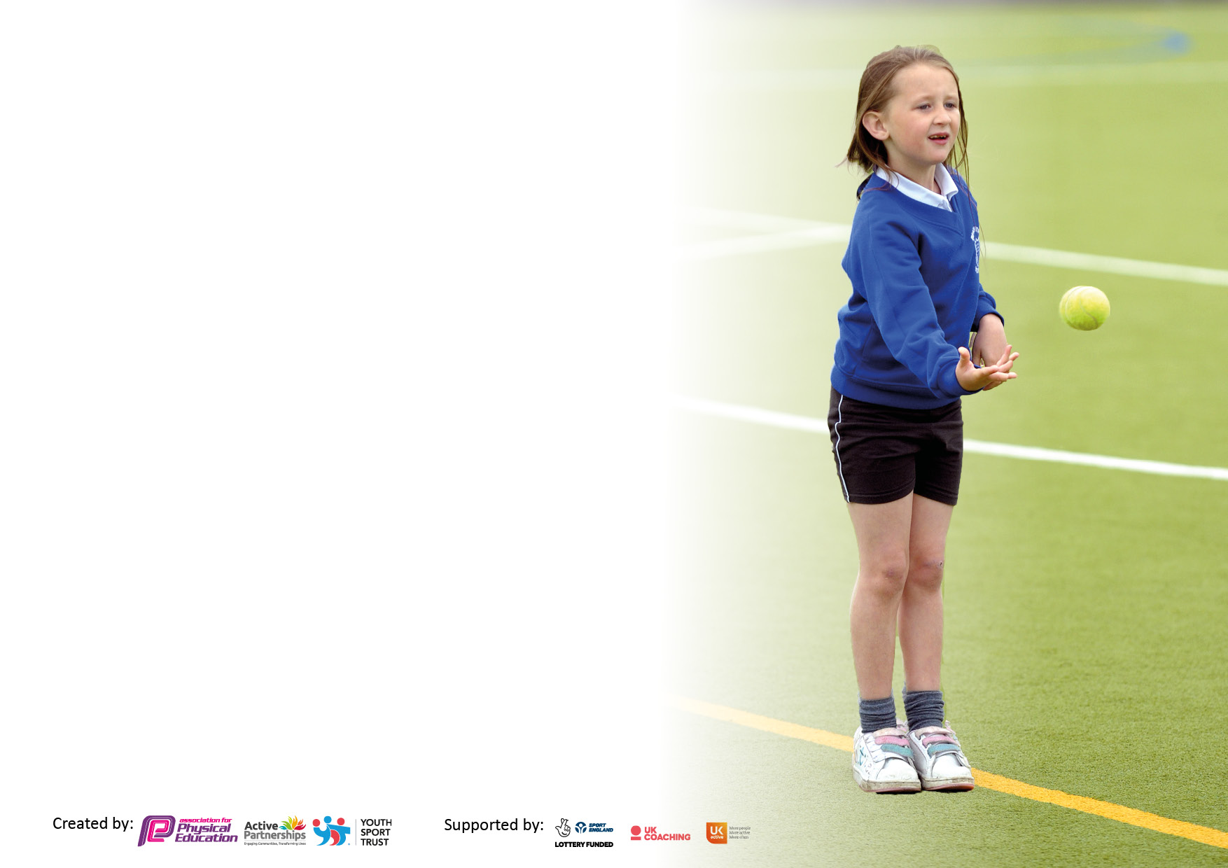

It is important that your grant is used effectively and based on school need. The Education Inspection Framework makes clear there will be a focus on **‘whether leaders and those responsible for governors all understand their respective roles and perform these in a way that enhances the effectiveness of the school’**.

Under the Quality of Education Ofsted inspectors consider:

**Intent** - Curriculum design, coverage and appropriateness

**Implementation** - Curriculum delivery, Teaching (pedagogy) and Assessment

**Impact** - Attainment and progress

To assist schools with common transferable language this template has been developed to utilise the same three headings which should make your plans easily transferable between working documents.

Schools must use the funding to make **additional and sustainable** improvements to the quality of Physical Education, School Sport and Physical Activity (PESSPA) they offer. This means that you should use the Primary PE and sport premium to:

* Develop or add to the PESSPA activities that your school already offer
* Build capacity and capability within the school to ensure that improvements made now will benefit pupils joining the school in future years
* The Primary PE and sport premium should not be used to fund capital spend projects; the school’s budget should fund these.

Pleasevisitgov.ukfortherevisedDfEguidanceincludingthe5keyindicatorsacrosswhichschoolsshoulddemonstrate animprovement.Thisdocumentwillhelpyoutoreviewyourprovisionandtoreportyourspend.DfEencouragesschools to use this template as an effective way of meeting the reporting requirements of the Primary PE and sport premium.

We recommend you start by reflecting on the impact of current provision and reviewing the previous spend.

Schools are required to publish details of how they spend this funding, including any under-spend from 2019/2020, as well as on the impact it has on pupils’ PE and sport participation and attainment. **All funding must be spent by 31st July 2022.**

We recommend regularly updating the table and publishing it on your website throughout the year. This evidences your ongoing self-evaluation of how you are using the funding to secure maximum, sustainable impact. Final copy must be posted on your website by the end of the academic year and no later than the 31st July 2021. To see an example of how to complete the table please click HERE.

Created by: Supported by:

**Details with regard to funding**

Please complete the table below.

|  |  |
| --- | --- |
| Total amount carried over from 2022-2023 | £0 |
| Total amount allocated for 2023-2024 | £16850 |
| How much (if any) do you intend to carry over from this total fund into 2023-2024 | £ |

**Swimming Data**

Please report on your Swimming Data below.

|  |  |
| --- | --- |
| Meeting national curriculum requirements for swimming and water safety.  N.B. Complete this section to your best ability. For example you might have practised safe self-rescue techniques on dry land which you can then transfer to the pool when school swimming restarts.  **Due to exceptional circumstances priority should be given to ensuring that pupils can perform safe self rescue even if they do not fully meet the first two requirements of the NC programme of study** |  |
| What percentage of your current Year 6 cohort swim competently, confidently and proficiently over a distance of at least 25 metres?  **N.B.** Even though your pupils may swim in another year please report on their attainment on leaving primary school at the end of the summer term 2024  Please see note above | N/A (Infant School) |
| What percentage of your current Year 6 cohort use a range of strokes effectively [for example, front crawl, backstroke and breaststroke]?  Please see note above | N/A (Infant School) |
| **What percentage of your current Year 6 cohort perform safe self-rescue in different water-based situations?** | N/A (Infant School) |
| Schools can choose to use the Primary PE and sport premium to provide additional provision for swimming but this must be for activity **over and above** the national curriculum requirements. Have you used it in this way? | Yes/**No** |

**Action Plan and Budget Tracking**

Capture your intended annual spend against the 5 key indicators. Clarify the success criteria and evidence of impact that you intend to measure to evaluate for pupils today and for the future.

|  |  |  |  |  |
| --- | --- | --- | --- | --- |
| **Academic Year:** 2023-2024 | **Total fund allocated: £16850** | **Date Updated: July 2024** | |  |
| **Key indicator 1:** The engagement of all pupils in regular physical activity – Chief Medical Officers guidelines recommend that primary school pupils undertake at least 30 minutes of physical activity a day in school | | | | Percentage of total allocation: |
| 46 |
| **Intent** | **Implementation** | | **Impact** |  |
| Your school focus should be clear what you want the pupils to know and be able to do and about  what they need to learn and to  consolidate through practice: | Make sure your actions to achieve are linked to your intentions: | Funding allocated: | Evidence of impact: what do pupils now know and what can they now do? What has changed?: | Sustainability and suggested next steps: |
| To continue to provide opportunities to experience new activities and also to provide extra opportunities for physical activity through sports clubs as additional physical time to the school day.  To educate children in safer road practice to enable them to walk to leisure centre/use their bikes safely in the community.  Provide sports kit for children unable to participate without provision | Sports companies to booked to provide clubs and a wider range of opportunities.  Road safety to be booked and come in to do sessions.  Purchase necessary kit | £7605.00  £140  £15.50 | PE lessons have been active and engaging – with staff benefitting from upskilling and new ideas from coaches. Regular sports club opportunities have been provided and as cost has been covered by PESSPA all children have been able to take part.  All year 2 children received road safety training.  All children able to participate in PE lessons as kits purchased and kept in school. | Plan to use funding in 2024-2025 in similar manner to encourage more children to take part – investigate other club opportunities.  As this is annual training we will need to look to continue this for the next group of children.  Childrne to come to school in kits. Spare sets to be kept in school |
| **Key indicator 2:** The profile of PESSPA being raised across the school as a tool for whole school improvement | | | | Percentage of total allocation: |
| 10 |
| **Intent** | **Implementation** | | **Impact** |  |
| Your school focus should be clear what you want the pupils to know and be able to do and about  what they need to learn and to  consolidate through practice: | Make sure your actions to achieve are linked to your intentions: | Funding allocated: | Evidence of impact: what do pupils now know and what can they now do? What has changed?: | Sustainability and suggested next steps: |
| Continued CPD for staff – new ECTs and returning staff  For PE lead to have time to lead audit of subject and resources and ensure that resources and planning are sufficient and effective.  Continue to ensure that lunchtimes are be more physically active and activities to be better supported and directed to ensure behaviour is improved. | Coaching support to support less experienced teachers.  TAs released to support audit and resource preparation.  PE lead to have release time regularly to support the teaching, assessment and planning in PE.  Sports providers to support with lunchtime support for chn with additional needs | Allocated £978  £775 | New staff upskilled and introduced to scheme and teaching ethos in school.  Support and advice sought from Martin Radmore to further this,  Staff to take on playing and leading games shown by sports coach on the other half of the playground also. | Provision outstanding |

|  |  |  |  |  |
| --- | --- | --- | --- | --- |
| **Key indicator 3:** Increased confidence, knowledge and skills of all staff in teaching PE and +++++++++++++++++++++++++++++++++++++++++++++++++sport | | | | Percentage of total allocation: |
| 0% |
| **Intent** | **Implementation** | | **Impact** |  |
| Your school focus should be clear | Make sure your actions to | Funding | Evidence of impact: what do | Sustainability and suggested |
| what you want the pupils to know | achieve are linked to your | allocated: | pupils now know and what | next steps: |
| and be able to do and about | intentions: |  | can they now do? What has |  |
| what they need to learn and to |  |  | changed?: |  |
| consolidate through practice: |  |  |  |  |
| See Indicator 1 |  |  |  |  |
| **Key indicator 4:** Broader experience of a range of sports and activities offered to all pupils | | | | Percentage of total allocation: |
| 45 |
| **Intent** | **Implementation** | | **Impact** |  |
| Your school focus should be clear | Make sure your actions to | Funding | Evidence of impact: what do | Sustainability and suggested |
| what you want the pupils to know | achieve are linked to your | allocated: | pupils now know and what | next steps: |
| and be able to do and about | intentions: |  | can they now do? What has |  |
| what they need to learn and to |  |  | changed?: |  |
| consolidate through practice: |  |  |  |  |
| To ensure all children experience a range of sport and other outdoor physical learning opportunities throughout the year. | Forest school time too be booked for all year groups and classes regularly throughout the academic year.  Skipping workshop to be booked | Supply cover costs  325.00 | Forest school time increased during the year for all children. More active outdoor learning took place and children were able to better engage in physical learning. | To be continued – possible development with parental engagement for 2024-2025 |

|  |  |  |  |  |
| --- | --- | --- | --- | --- |
| **Key indicator 5:** Increased participation in competitive sport | | | | Percentage of total allocation: |
| % |
| **Intent** | **Implementation** | | **Impact** |  |
| Your school focus should be clear | Make sure your actions to | Funding | Evidence of impact: what do | Sustainability and suggested |
| what you want the pupils to know | achieve are linked to your | allocated: | pupils now know and what | next steps: |
| and be able to do and about | intentions: |  | can they now do? What has |  |
| what they need to learn and to |  |  | changed?: |  |
| consolidate through practice: |  |  |  |  |
| Not a focus this year for our school |  | £ |  |  |

|  |  |
| --- | --- |
| Signed off by | |
| Head Teacher: |  |
| Date: |  |
| Subject Leader: |  |
| Date: |  |
| Governor: |  |
| Date: |  |