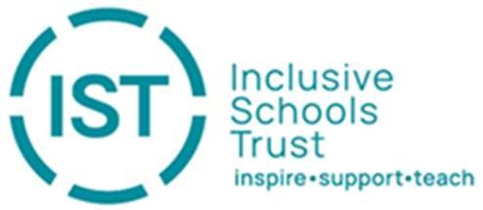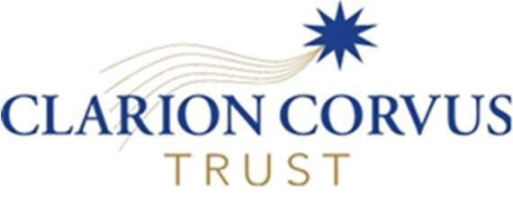

February 13th 2026
Dear parent/carer/colleague,
Following our previous communications regarding the proposed merger between Clarion Corvus Trust (CCT) and Inclusive Schools Trust (IST), we are delighted to provide you with a significant update.
Following approval from the Department for Education, both Boards of Trustees have now concluded a thorough due diligence process. Having reviewed all legal, financial, and operational issues, the Trustees of both CCT and IST have formally resolved to merge.
This merger will officially take place on 1st September 2026. As we previously indicated, the name would likely recognise the contributions of both current organisations. We are proud to share that the new Trust will be known as the Clarion Inclusive Trust (CIT).
The creation of CIT is driven by our shared aim of providing all our young people, employees and communities with the best environment to flourish. By bringing our schools together, we will benefit from:
- Enhanced educational opportunities and better-connected schools.
- Increased capacity and expanded professional networks for our staff.
- Greater flexibility with resources and access to increased capital funding for school environments.
We want to reassure you that while the Trust is evolving, the individuality of our schools remains a priority. There are no plans to change the way our schools work or to change school uniforms. Furthermore, all staff contracts and terms and conditions are protected by law and will be honoured by the new Trust.
The leadership of Clarion Inclusive Trust will draw on the expertise of both existing organisations. Jim Adams will serve as CEO, focusing on finance, HR, and Trust growth, while Selene Sawyer will take up the role of Deputy CEO. She will focus on school improvement, SEND, and people development. The new Board of Trustees will also be formed from the current members of both merging Trusts.
We would like to thank you for your continued engagement and support throughout this consultation and due diligence period. We look forward to beginning this new chapter as the Clarion Inclusive Trust and continuing to work together to provide the very best for our pupils, staff, and communities.
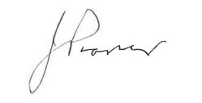
Yours faithfully,
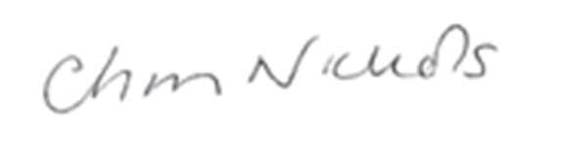
Ms Christine Nichols (Chair of CCT) Mr Jeff Prosser (Chair of IST)

