Understanding the World
Learns that they have similarities and differences to their friends. Stem learning, exploring natural materials indoors and outside. Noticing seasonal changes. Notice difference between people, people who help us. Celebrations & festivals.

Physical Education
Health and Self Care
Beginning to be independent when using the toilet and ask for help when needed
Learn daily routines and handwashing
Eat and use utensils with greater independence
Movement
Experiment with different ways of moving.
Begin to negotiate space successfully when walking, running and hopping. Explore bikes, scooters and other wheeled toys

Expressive Arts and Design
Painting and Colour
Explore mixing colour and a range of different tools freely
Printing
Participate in hand, finger, printing
Music
Watching, listening & participating- -Find our singing voices and exploring vocal sounds.

Core Story
The Something by Rebecca Cobb
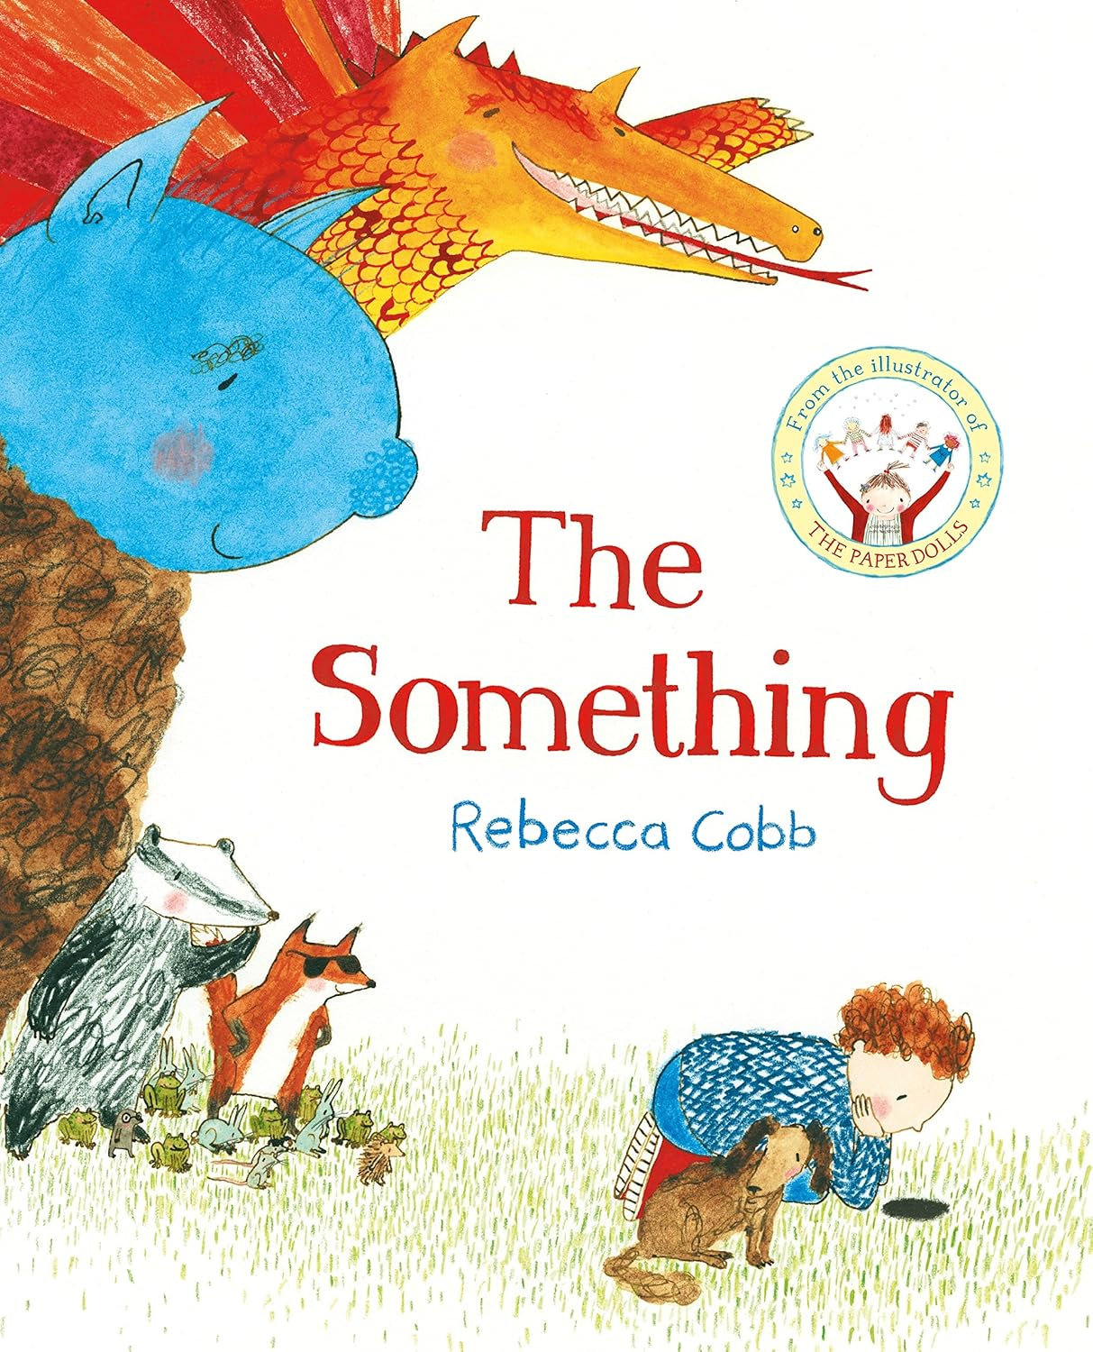

Personal, Social, Emotional Development
Settling into our Nursery
Get to know and develop relationships
Play name games
Learn areas of the classroom and school routines Learn to hang my things on my special peg
Share pictures of the our families/important people
Setting rules and routines; expectations and boundaries
We will explore the story
The Kissing Hand by Audrey Penn
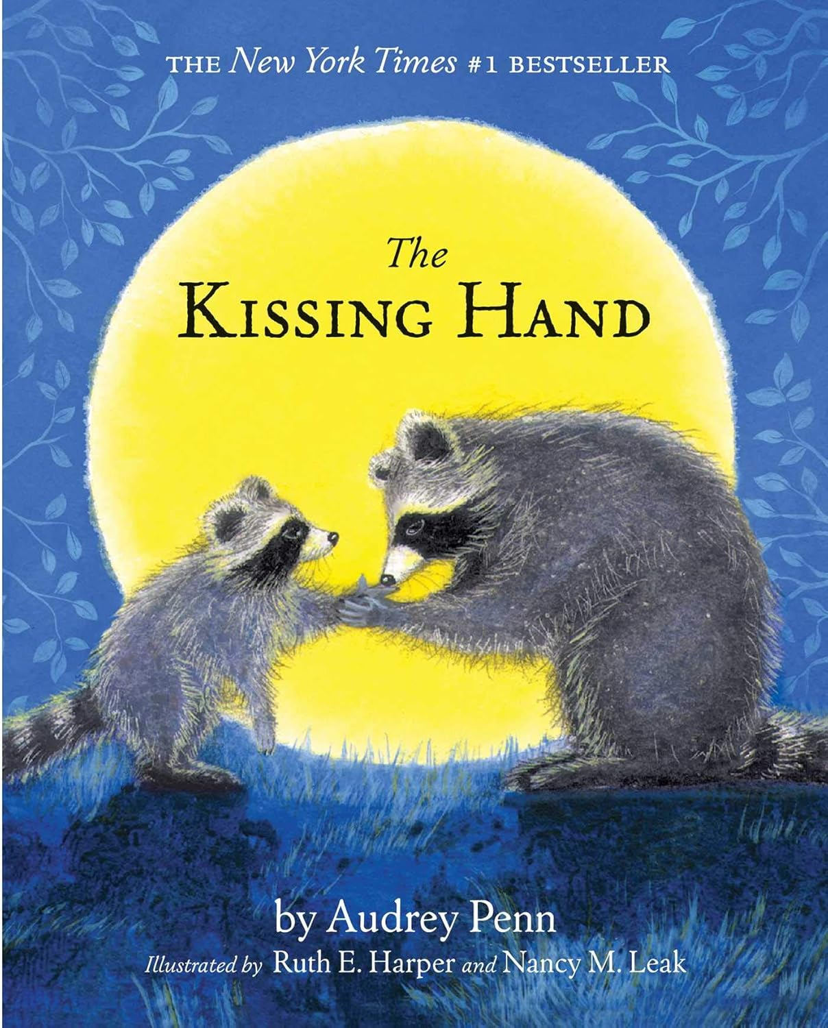

hole class.

Alongside using the statutory framework for the early years curriculum and birth to five matters to inform planning, we also take into consideration the children’s individual interests, needs and abilities. Part of our planning is based on the interests the children show during their free flow play.
Communication and Language
Learn rhymes and songs that use the whole hand. Children talk about experiences that are familiar to them. Explore feelings and emotions. Nature walk, what can you see and hear? Verbally retelling stories using with actions.
Maths
Join in with number songs and rhymes
Count my fingers in sequence
Notice numbers in the environment
Explore number 1
Recognise Colours
Explore matching and sorting

Literacy
Fine motor and mark making
Rolls, pounds, squeezes and pulls play dough
Hold and use a range of small tools and objects such as tambourines, jugs, hammers and mark making tools
Begin to turn pages in a book
Reading
Share favourite stories/songs/rhymes
Join in with actions to rhymes and stories
familiar stories -Use Story Sacks during story time

Nursery Medium Term Plan Autumn 101

